**EXP NO: 14 DATE:15-03-24**

**Aim:** To Create a Snapshot of a VM and Test it by loading the Previous Version/Cloned VM.

**Implementation:**

1.install and setup VM ware software and create a new virtual machine

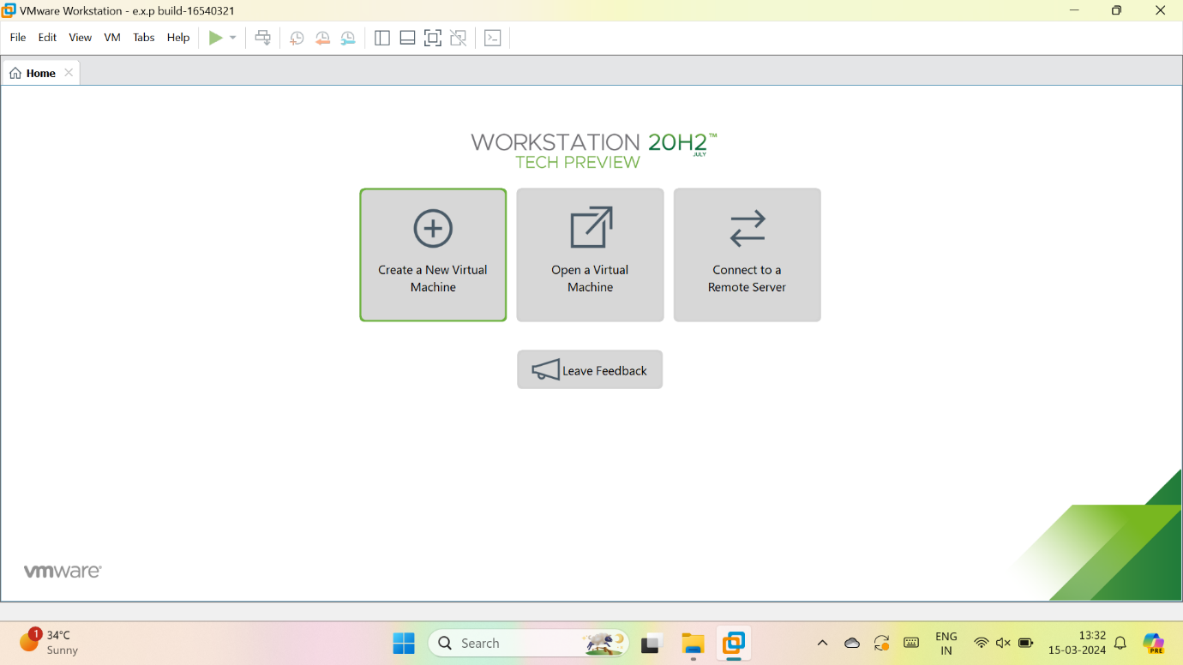

2.select typical

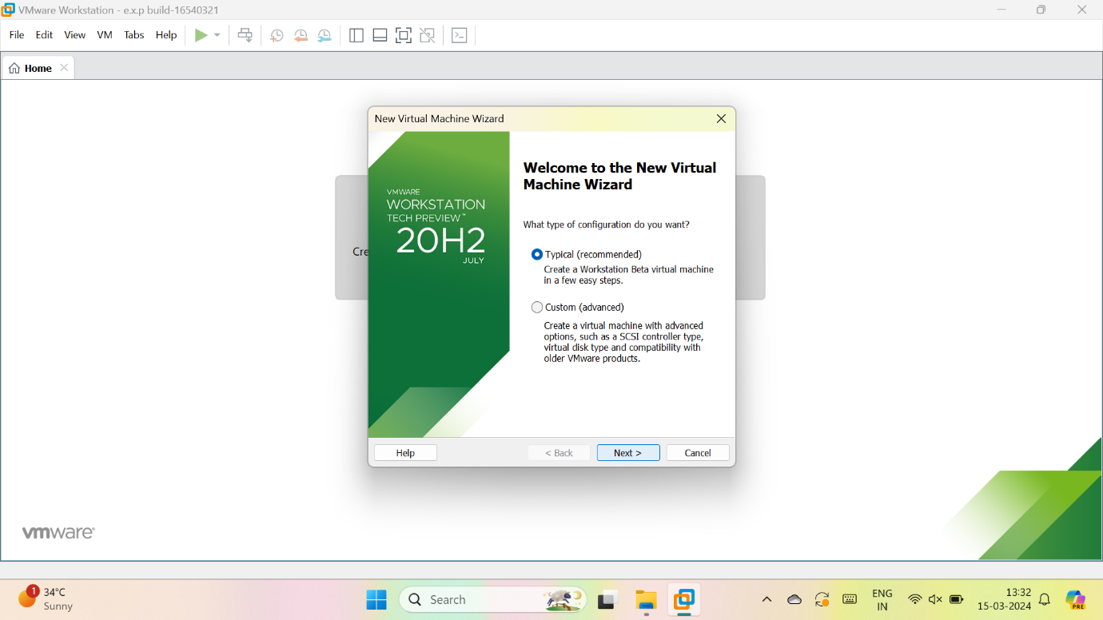

3.we have to select, I will install the OS later

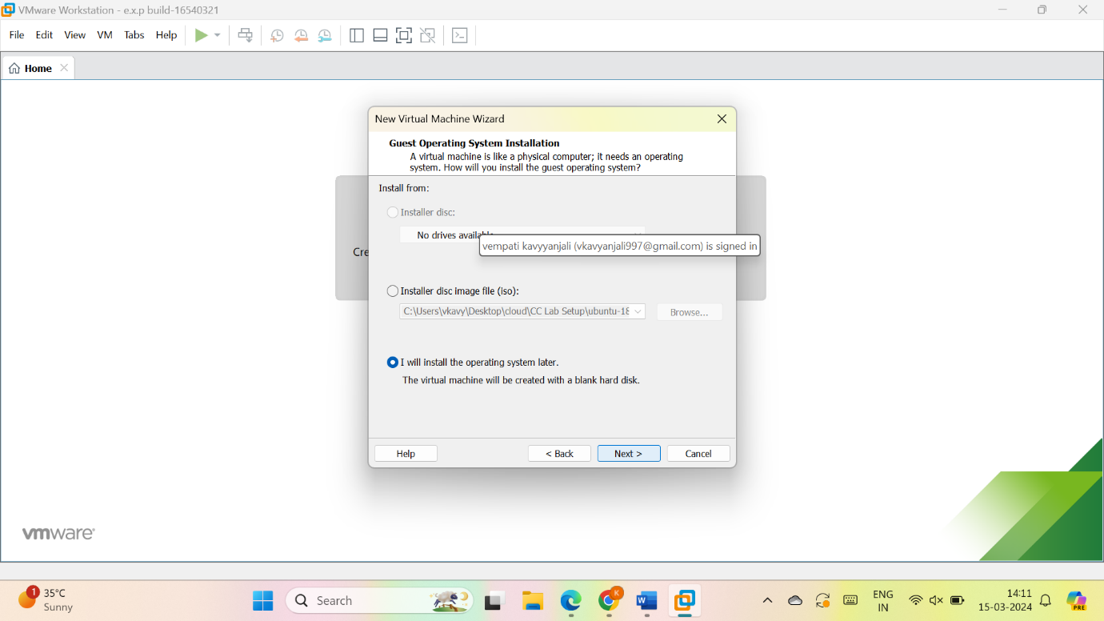

4.give name for VM

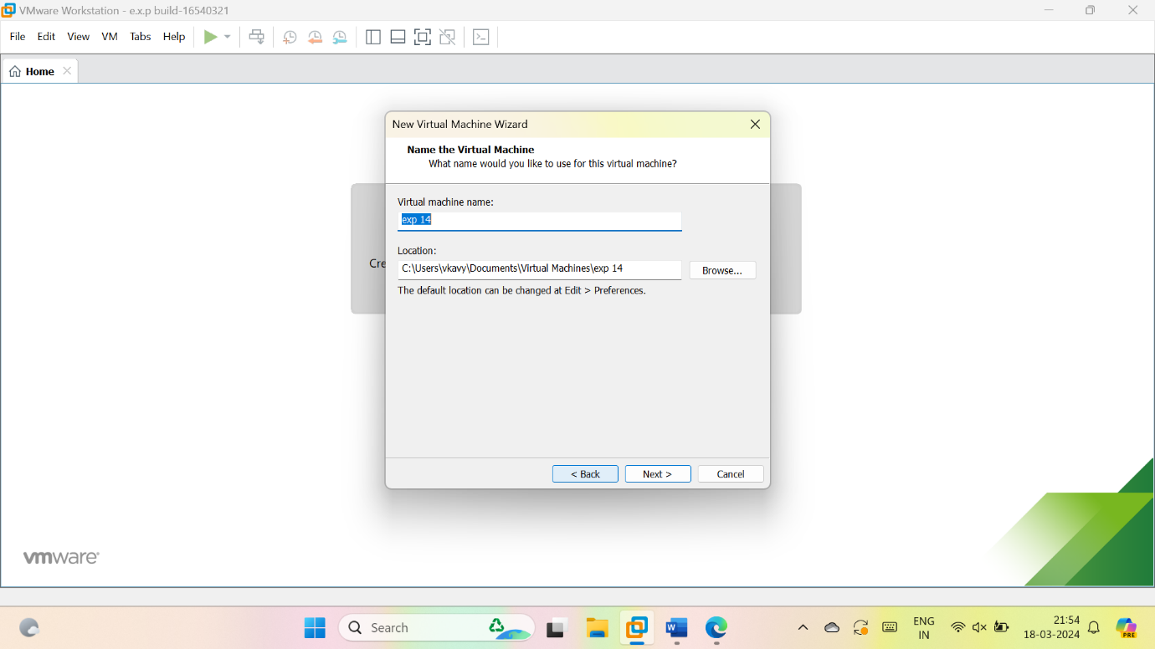

5.give the maximum size of disk as 15GB and select, store virtual disk as a single file and give next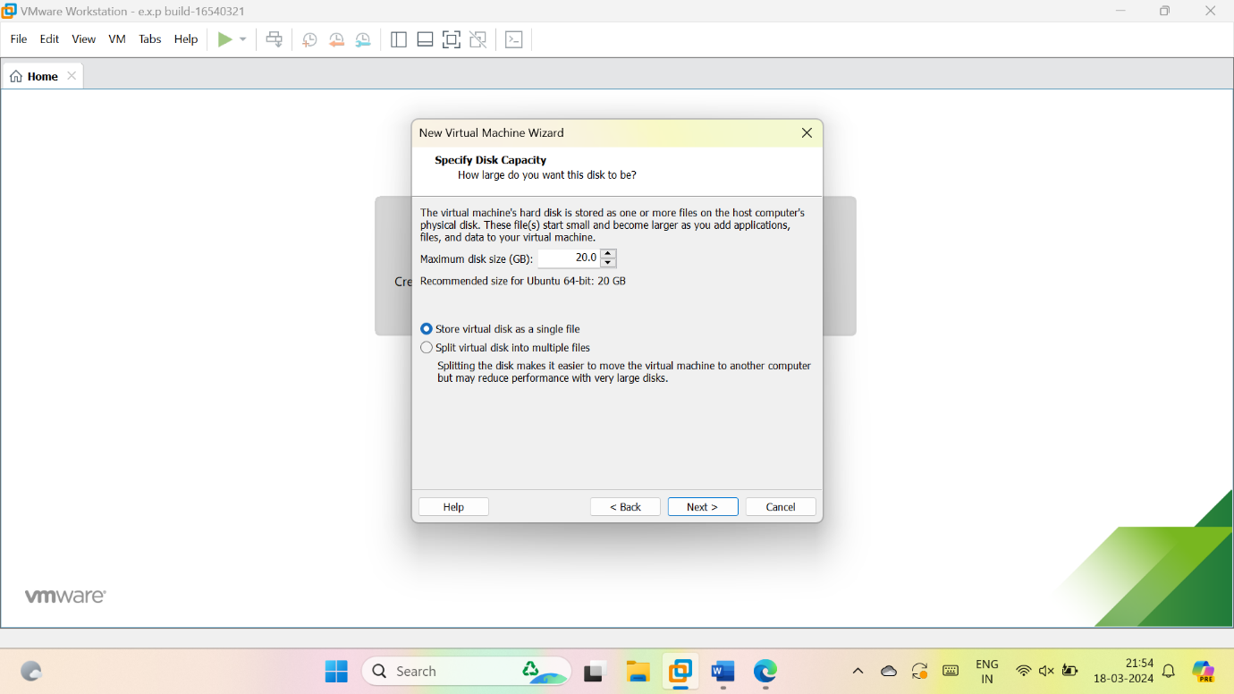

6.check the description

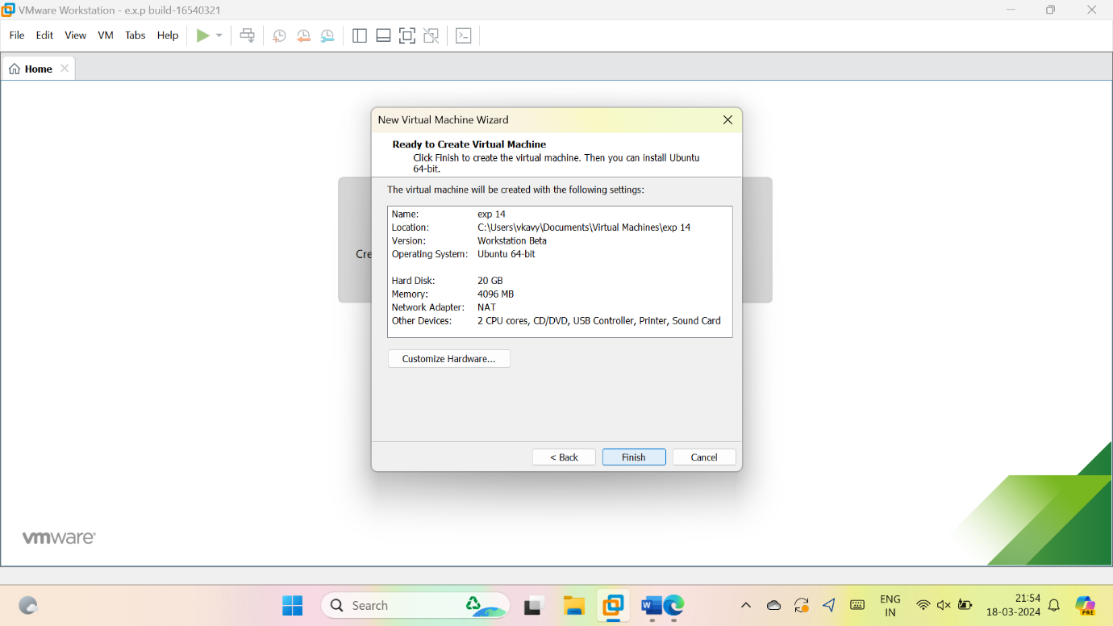

7.vm is created

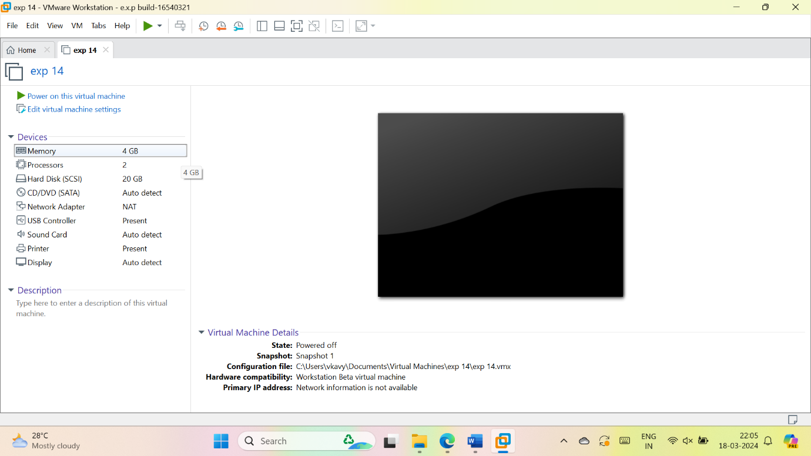

8. to take snapshot:

go to VM in task bar

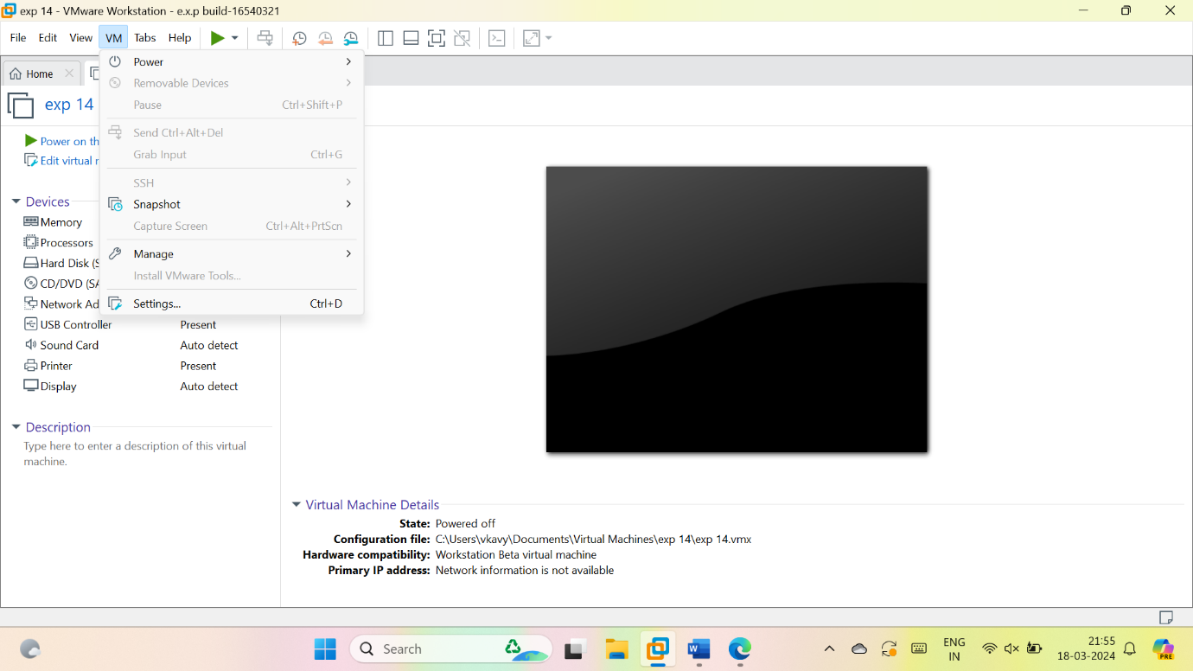

Select snapshot > take snapshot

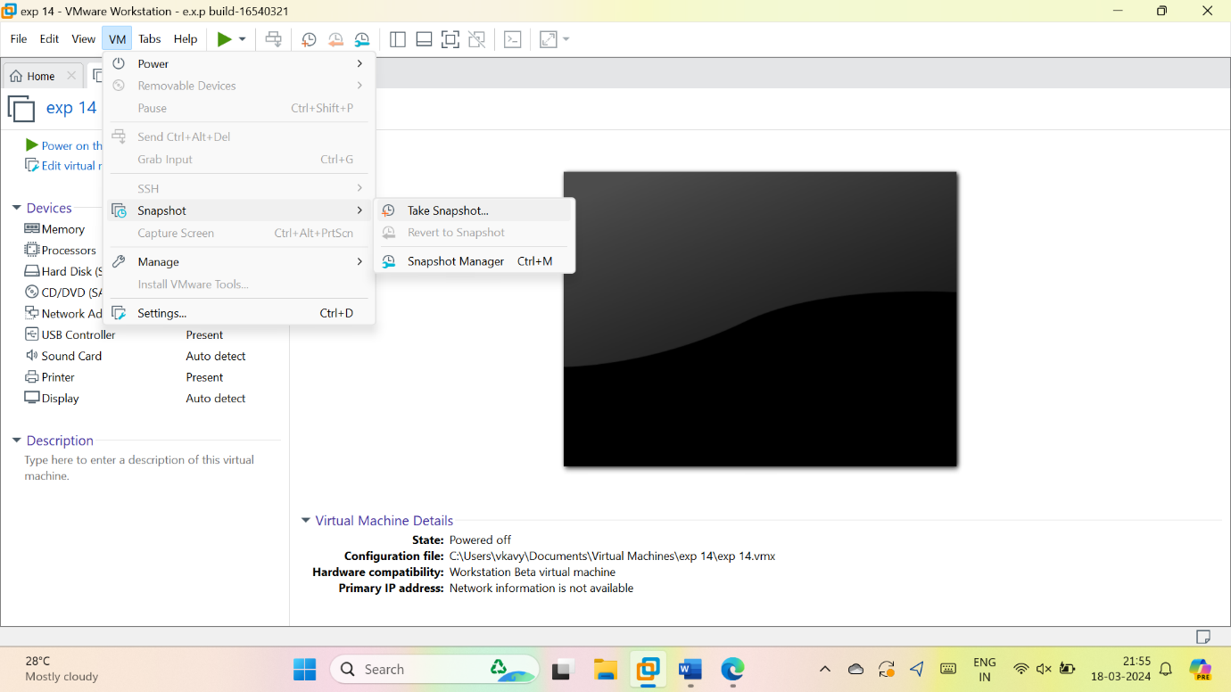

9.Take snapshots:

By changing the description; like memory, processor, etc

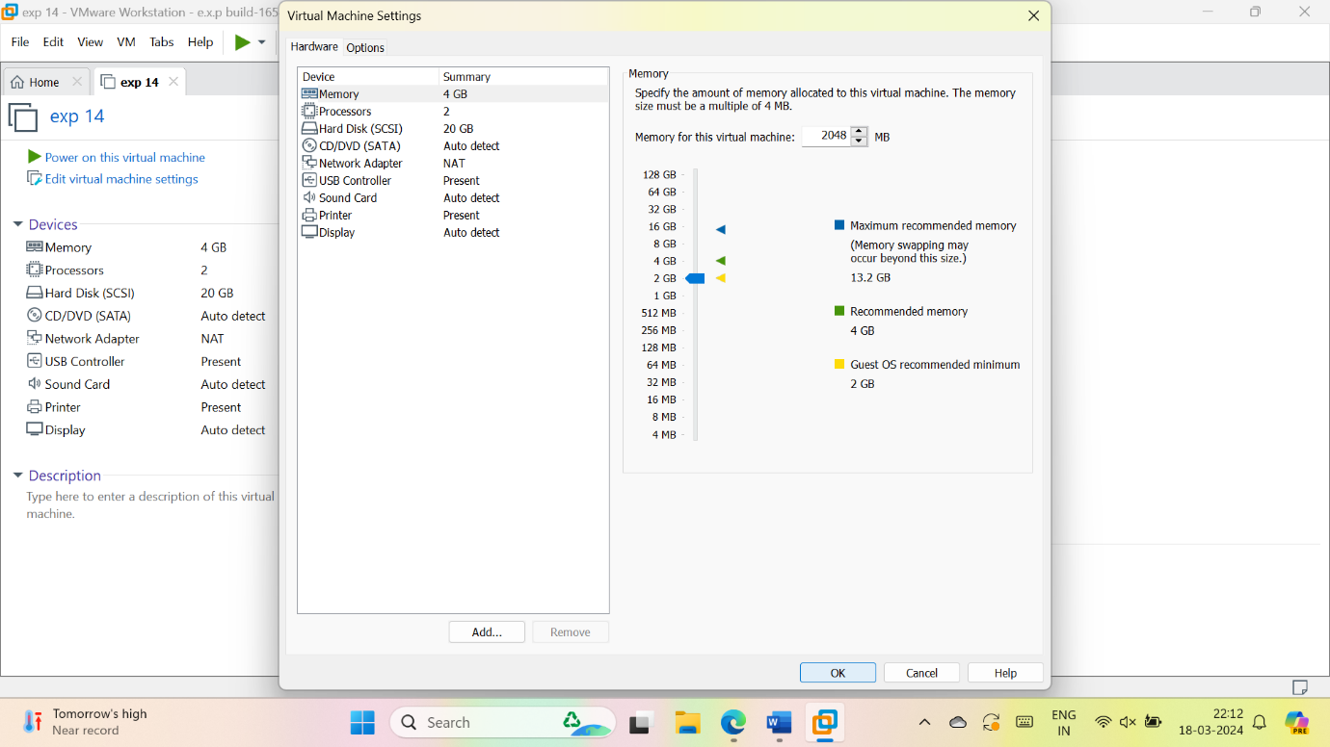

**Snapshots**:

Snapshot 1

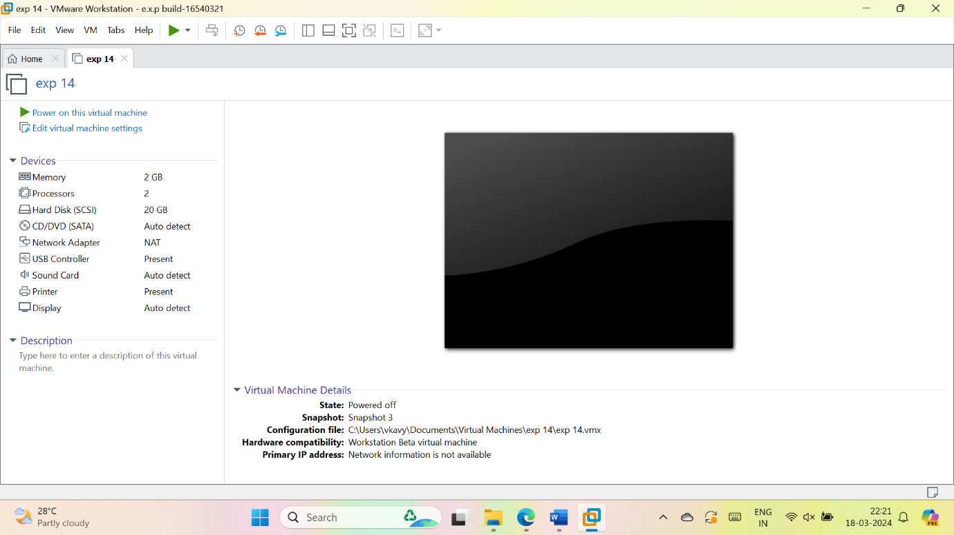

Snapshot 2

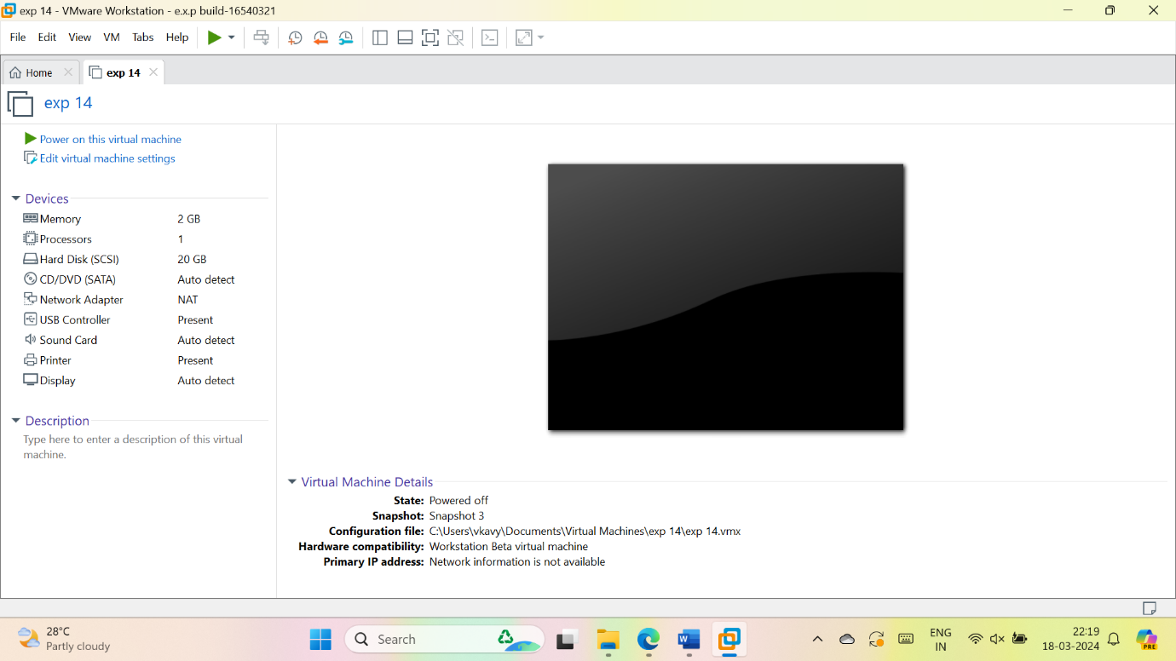

Snapshot 3

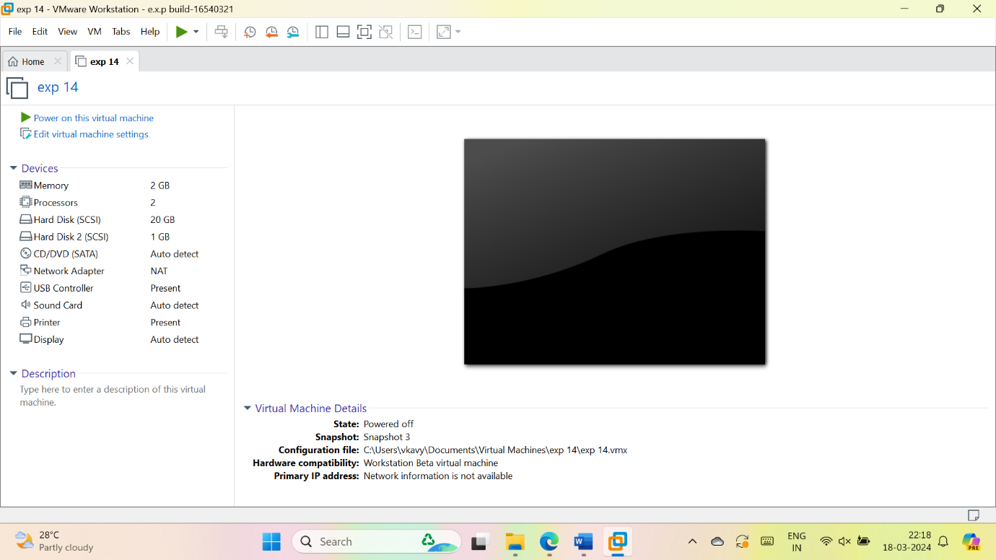

10. go to VM > snapshot > snap short manager

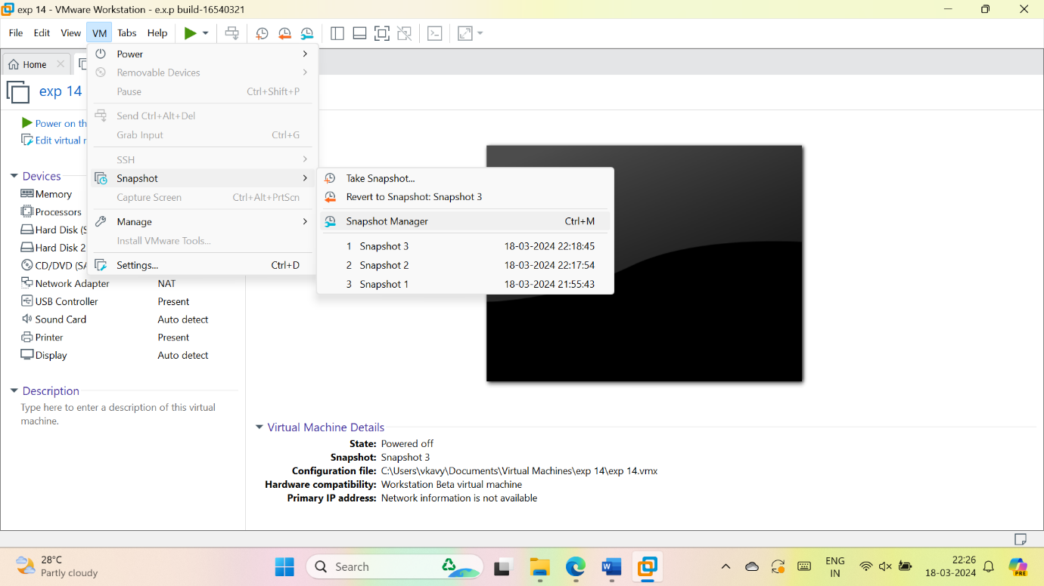

11. select a snapshot

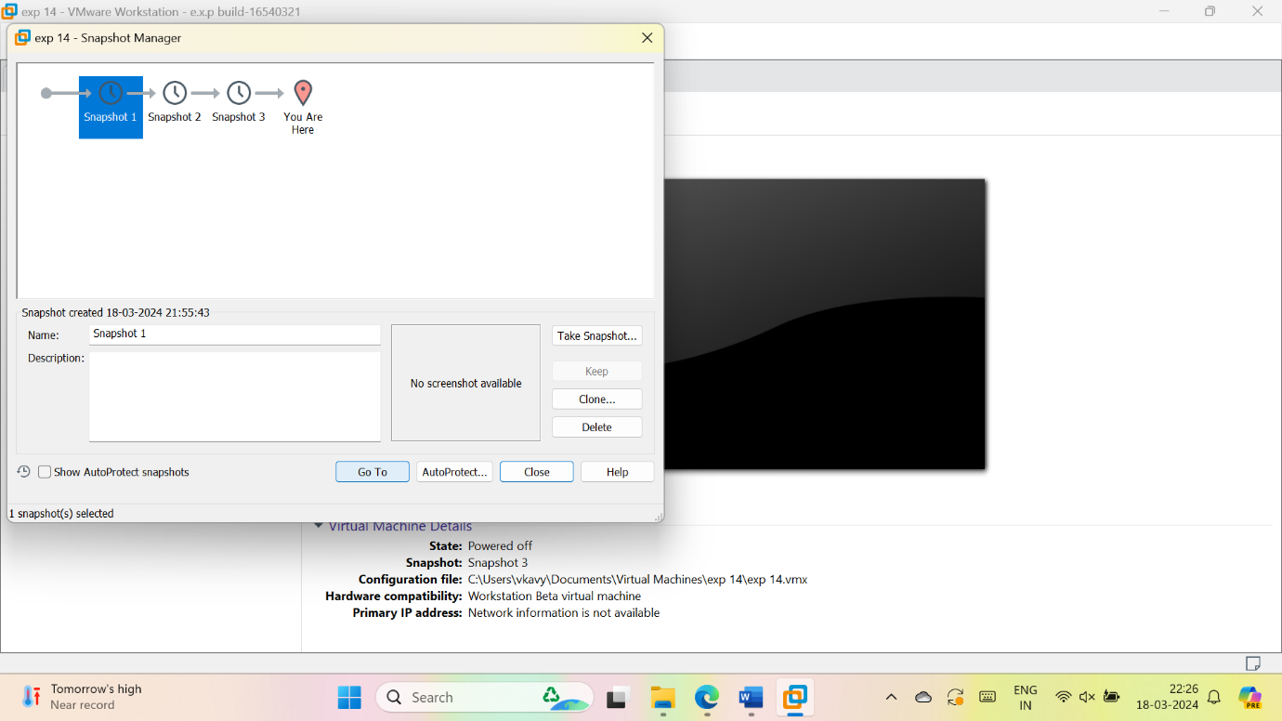

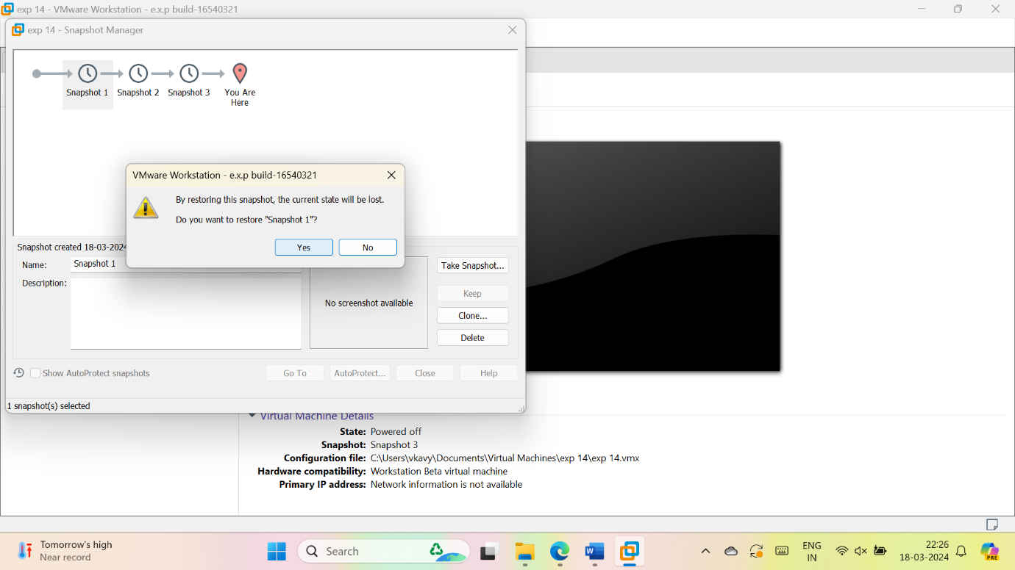

12.the resulted VM description after snapshot